15_Discover_Share Report (Vlookup)
Report Views
Standard View
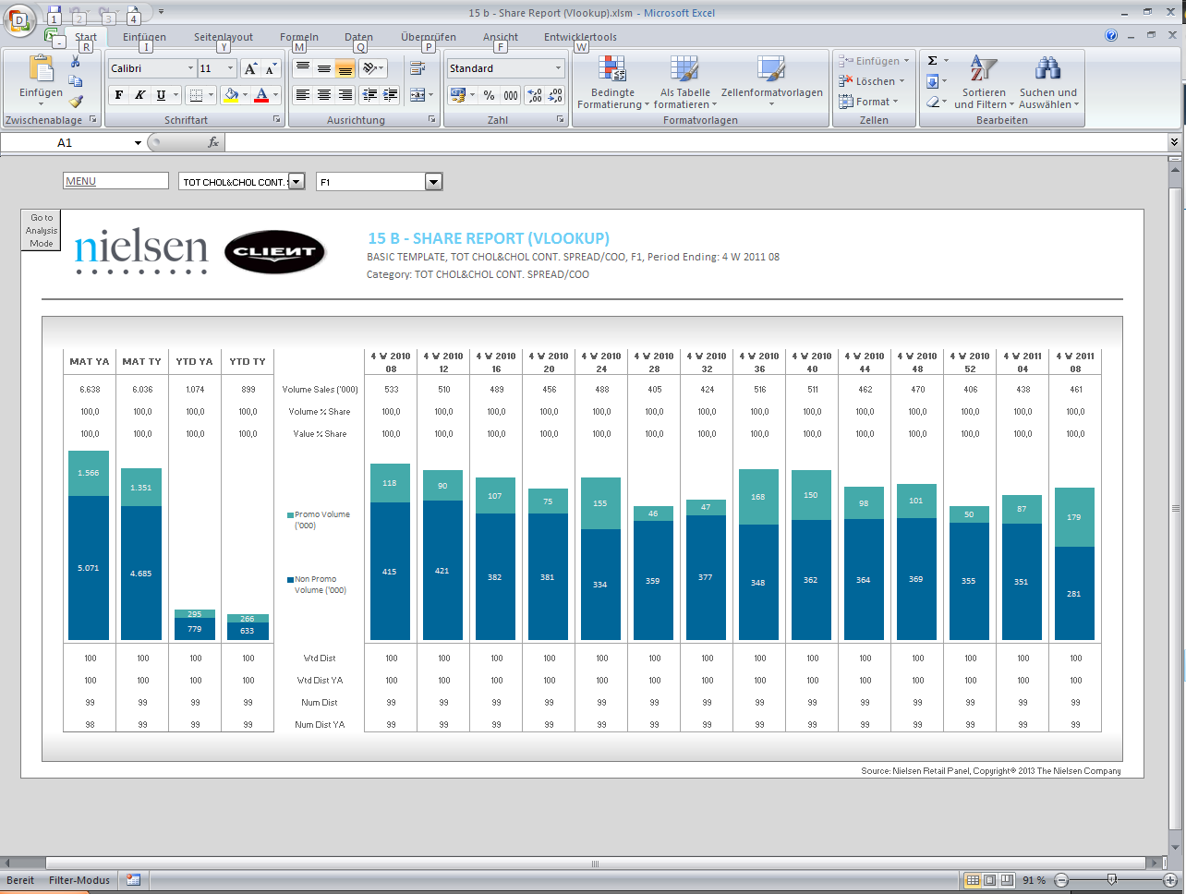

Standard View
Guidelines
Template Name | 15_Discover_Share Report (Vlookup)
View Name | Standard View
Methodology | VLOOKUP
Default Dimension Order (WSP) | Page Bar
Default Dimension Order (WSP) | Columns | 1 Dimensions | Periods
Default Dimension Order (WSP) | Rows | 1 Dimension | Markets, Products, Facts
Change dimension | - The dimensions can’t be swapped  - If a different layout is needed (for example, 2 dimensions on the columns) please select a different template  - The dimensions are following the Default Dimension order  - Dimension in Drop Down 1: First Position in Data set Rows  - Dimension in Drop Down 2: Second Position in Data set Rows  - Dimension in Row Table: Third Position in Data set Rows  - Dimension in Template Columns: in Data set Column
Data Selection Guidelines | Facts | - Number of facts are limited to maximum 10 in the first table, 2 in the chart, and maximum of 36 facts in the second table  - Facts’ selection always starts with the facts for the first table, followed by a „divider fact”, the 2 facts for the chart (in the order as it is shown in the template) and directly below the facts for the second table.  - Divider fact needs to be added to the configuration area, into cell J10, for example „Sales Value 2YA”. This fact is not going to be displayed in the final report. Its purpose is to split facts into groups for the table and chart.  - 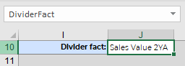  - Example:
  Sales Value
  Sales Value YA
  Sales Value Chg YA
  Sales Value % Chg YA
  Sales Value Index YA
  Sales Value 2YA
  Weighted Distr (w)
  Weighted Distr (w) YA
  Avg. Any Promo Price Units
  Any Promo Sales Value…
Data Selection Guidelines | Products | - No limitation in number (except limitation on dropdown lists)  - Product selection starts with the total Category followed by the products for the report
Data Selection Guidelines | Markets | - No limitation in number (except limitation on dropdown list)
Data Selection Guidelines | Periods | - 4 periods Maximum for Table or Chart at the left side, Maximum 14 periods Maximum for the table or Chart at the right side. These limitations are only due to layout, so all the report can fit in one page.
Data Selection Guidelines | NOTE: For the dimension in the Page Bar, the maximum number of items is 100  IMPORTANT:  - If report performance is poor, i.e., file opening and changing drop down selections take longer than several seconds (not acceptable by end user), remove any unused data rows from each Output Sheet, to improve user experience.  *Poor performance can be observed mostly in reports with multiple Output Sheets.  Example Scenario:  *Before removing rows, ensure you do not remove any important part of report configuration area.  RATIONALE: Individual cells in each row contain formulas, which need to be re-calculated every time a report is opened or drop down selection is changed. These additional operations, which run in the background, can negatively impact report performance, e.g. in a template with 40 formulas per row and 390 unused rows, the number of unnecessary operations is ~15600.
  Description | # Rows
  Default number of data rows handled by template | 500
  Number of items in rows (current report selection) | 60
  Buffer for any fluctuations in rows (deletions/additions of items in the future) | 50
  Unused number of data rows to be removed | 500-(60+50) = 390
To create a new report from this template | - Welcome Sheet – Check if the Configuration Area are filled in by the correct information.  - Output Sheet – Insert all the needed information on the first Row in the Parallel of the Table, if you add more Columns.  - Add or delete the needed columns to accommodate the retrieved information  - Never delete column outside the print Area.  - Depending on the number of periods, the table formatting and Charts will have to be adjusted.  - To make formatting easier, the existing formats can be copied  - When the new source Sheet is created, you have to run the following Macro: InsertColumns()

